**DAILY ONLINE ACTIVITIES SUMMARY**

|  |  |  |  |  |  |  |  |  |
| --- | --- | --- | --- | --- | --- | --- | --- | --- |
| **Date:** | **13/07/2020** | | | | | **Name:** | **NIKHIL KUMAR** | |
| **Sem & Sec** | **4thSEM. & ‘B’ SEC.** | | | | | **USN:** | **4AL19CS400** | |
| **Online Test Summary** | | | | | | | | |
| **Subject** | | **MICROCONTROLLER AND EMBADDED SYSTEM** | | | | | | |
| **Max. Marks** | | **30** | | **Score** | | |  | |
| **Certification Course Summary** | | | | | | | | |
| **Course** | Front-End Web UI Frameworks and Tools: Bootstrap 4 | | | | | | | |
| **Certificate Provider** | | | **Coursera** | | **Duration** | | | **4week** |
| **Coding Challenges** | | | | | | | | |
| **Problem Statement1:---** Write a Java Program to find the duplicate characters in a string. | | | | | | | | |
| **Status: ---executed** | | | | | | | | |
| **Uploaded the report in Github** | | | | | **Yes** | | | |
| **If yes Repository name** | | | | | <https://github.com/Nikhil401/java-coding/blob/master/DuplicateCharacterss.java> | | | |
| **Uploaded the report in slack** | | | | | **Yes** | | | |

**Online Test Summary : Subject microcontroller and embedded system IA test Descriptive was conducted from module:1 there were 3 question and time assigned from 09:30 to 10:15**

**Certification Course Summary: Today my task was to give some ideation report regarding to websites as shown in the snapshot….**

**Snapshot is given below**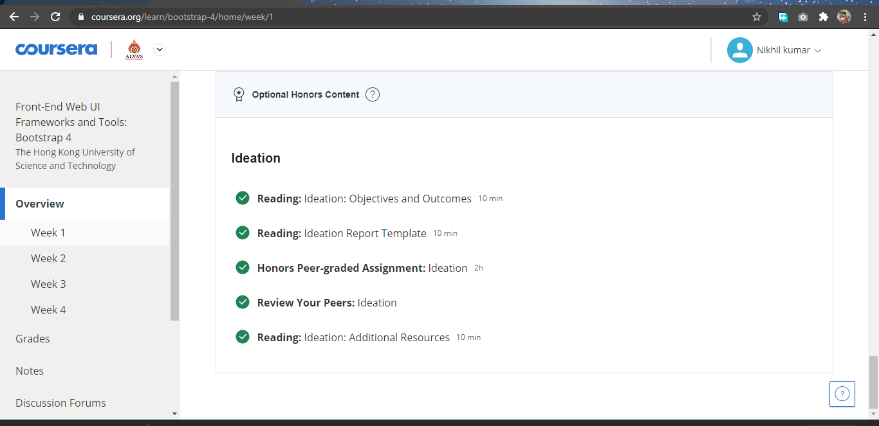

**Online coding summary: Today I had received programs which is mentioned in table above and I have uploaded into the github repository. Snapshot of the program is given below:**

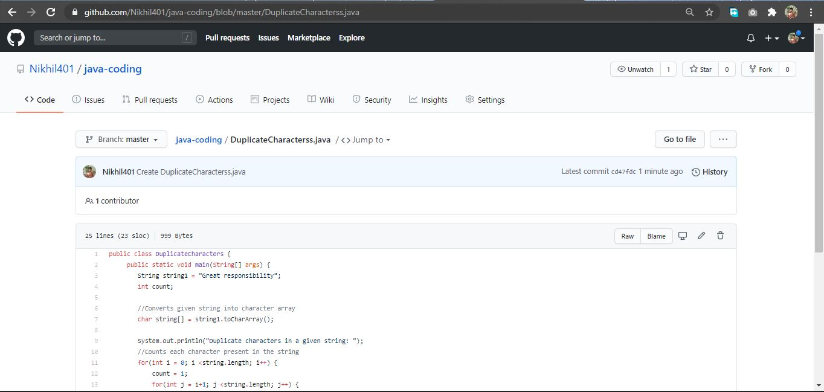

**Thank you.**